**Assignment - 2**

**Ans 1.** Yes,the ODBMS is capable of storing complex objects within itself. The structure of an object refers to the properties that an object is made up of. These properties of an object are referred to as an attribute. Thus, an object is a real world entity with certain attributes that makes up the object structure. Also an object encapsulates the data code into a single unit which in turn provides data abstraction by hiding the implementation details from the user.

**Ans 2.** Several standards are expressed using XML Schema syntax, since the XML is the default standard for data exchange in the Internet. However, several applications need semantic support offered by domain ontologies and semantic Web tools like logic-based reasoners. Thus, there is a strong need for interop erability between XML Schema and OWL. This can be achieved if the XML schema constructs are expressed in OWL, where the enrichment with OWL domain ontologies and further semantic processing are possible. After semantic processing, the derived OWL constructs should be converted back to instances of the original schema. We present in this paper XS2OWL, a model and a system that allow the transformation of XML Schemas to OWL-DL constructs. These con structs can be used to drive the automatic creation of OWL domain ontologies and individuals. The XS2OWL transformation model allows the correct conver sion of the derived knowledge from OWL-DL back to XML constructs valid according to the original XML Schemas, in order to be used transparently by the applications that follow XML Schema syntax of the standards.

**Ans 3.**

1. **SQL:1999** (also called SQL 3) was the fourth revision of the SQL database query language. It introduced many new features, many of which required clarifications in the subsequent SQL:2003. In the meanwhile SQL:1999 is deprecated.
2. **SQL:2003** is the fourth revision of the SQL database query language. The standard consists of 9 parts which are described in detail in SQL. It was updated by SQL:2006.

**Ans 4.**

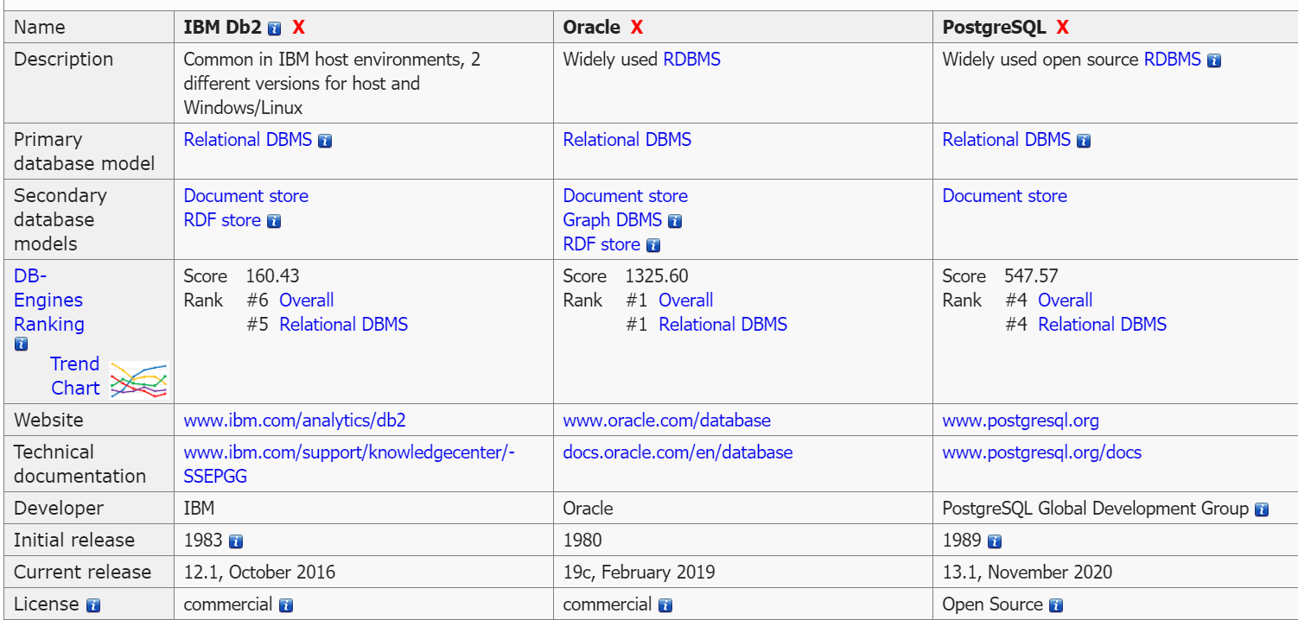

**Ans 5.**

1. **SOAP :** SOAP ( Simple Object Access Protocol) is a message protocol that allows distributed elements of an application to communicate. SOAP can be carried over a variety of lower-level protocols, including the web-related Hypertext Transfer Protocol (HTTP).
2. Semi-structured data is a form of structured data that does not conform with the formal structure of data models associated with relational databases or other forms of data tables, but nonetheless contain tags or other markers to separate semantic elements and enforce hierarchies of records and fields within the data.

**Ans 6.** The term "native XML database" (NXD) is deceiving in many ways. In fact many so-called NXDs aren't really standalone databases at all, and don't really store the XML in true native form (i.e. text). To get a better idea of what a NXD really is, let's take a look at the NXD definition offered by the XML:DB Initiative, of which the author is a participant.

**Ans 7.**

* XSD is extensible. You can derive new elements from the existing elements. DTD is not extensible.
* XSD is defined in XML. It does not require intermediate processing by a parser. DTD is not defined in XML. You need separate parsers for DTD and XML.
* XSD supports data types. You can restrict the content of an element. DTD does not support data types. Therefore, you cannot restrict the content of an element.
* XSD supports default values. You can specify default values of the elements. You cannot specify the default values of elements in DTD.

**Ans 8.**

* A spatial database is a database that is optimized for storing and querying data that represents objects defined in a geometric space. Most spatial databases allow the representation of simple geometric objects such as points, lines and polygons.
* A temporal database stores data relating to time instances. It offers temporal data types and stores information relating to past, present and future time. The temporal database has two major notions or attributes. 1. valid time. 2. transaction time. More specifically the temporal aspects usually include valid time and transaction time. These attributes can be combined to form bitemporal data.